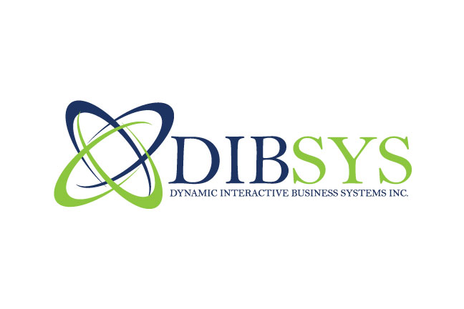
Dynamic Interactive Business Systems Inc.
7 Snead Court, Bolingbrook, IL 60490
Phone: +1 (630) 364 - 1354
Phone: +1 (630) 759 - 6703
Phone: +1 (510) 375 - 1537
Fax: +1 (630) 364 - 1354
Email: dsaha@dibsysinc.com
Website: www.dibsysinc.com
Software Testing and Methodology

Business Environment
Companies are not diligent about tracking the costs of software failure. In general, there is no budgetary approval, and thus there is little or no monitoring. Application failures account for significant financial losses and 40% of all downtime.

DIBSYS Inc.’s IT Software Testing Solution Offering provides direction, planning, documentation and closure to help your IS & IT organization manage and deploy defect free applications, enhancements and maintenance releases cost-effectively with minimal risk and maximum confidence.

DIBSYS Inc.’s IT proprietary software testing methodology covers the following activities:
- Assessment
- Methodology Implementation
- Testing Strategy and Planning
- Management and Execution
- Test Automation For ROI

DIBSYS Inc.’s IT develops customized test plans matching each client’s needs and mentors clients on the use of methodology and tools to ensure continued best practices. We also tests application developed by other software vendor and IT services providers – a unique capability in the industry.

Value Proposition
The Quality Assurance Institute (QAI) has demonstrated that the relative cost of correcting a defect during operation can escalate to 60-100 times the cost of fixing that same fault during the early development stages. Therefore early testing is critical.

With a software testing methodology and strategy, you can decrease defects by 200% in the first year and reduce downtime 50% by making your system components more resilient in the event of failures.

Where is your Pain-Point?
Case 1: Costs related to software development failures and defects are out of control.
Our Team Integrates Quality Assurance into all phases of the software development life cycle and leads your organization through a disciplined, repeatable proprietary methodology which detects errors and problems early. You significantly reduce the cost of rework, minimize system failures and outages and restore credibility. You also know exactly what you’re spending on IT and what return you’re getting for your investment.

Case 2: We are not getting new applications into production fast enough to reap competitive advantage.
Our IT experience, proven testing techniques, methodology and industry best practices ensure a rapid development life cycle and speed-to market. We agree on an engagement’s success criteria upfront and contractually commit to it.

Case 3: Our software testing procedures are not meeting our needs.
Through a Software Testing Assessment and analysis of your processes and procedures, Our Team identifies strengths and improvement opportunities in your existing testing process. We transfer knowledge to your staff for self management of your applications.

Case 4: We need to upgrade to new versions of software packages, but don’t have the manpower, space or computers to do it.
DIBSYS IT solves your space or disruption problems by performing some or all of the service remotely. You also free up your scarce IT resources to focus on key strategic issues.
1
Case 5: We are not meeting our completion targets.
We begin planning early in the Software Development Life Cycle (SDLC). The various phases of our proprietary testing methodology each builds on the solution’s success. We obtain end-user input to reduce the amount of rework during implementation.

Case 6: Testing the releases in house is becoming too costly.
Move testing offshore to DIBSYS IT’s Offshore Delivery Center (ODC) for 50-60% lower cost.

Why DIBSYS IT
Our Software Testers and analysts are certified by the Quality Assurance Institute (QAI). Our proprietary Quality Assurance and Software Testing Methodology are based on the work of the Software Engineering Institute’s (SEI) Capability Maturity Model® (CMM), IEEE standards, ISO 9000 and the Quality Assurance Institute. Testing consultants are certified in cutting edge testing tools.

Our IT Software Strategy is designed both to detect software defects, as well as prove that the software performs as predicted. Combining both strategies ensures that defects are proactively identified and eliminated.

Your Benefits
- Predictable production of your software initiative
- Software compliance
- Reduced cost of rework
- Speed to market
- Skilled support for lean IT departments
- Credibility with customers
- Reduced risk
- Increased customer satisfaction
- Improved application system performance and response time
- Enhanced asset value of your application portfolio
- Streamlined business operations, processes and transactions

Case Studies
Insurance Provider
Our Team provides QA and testing services for various insurance products. The objectives were to improve the stability of the systems by rolling out repeatable methodologies and to raise the awareness of the product groups to appropriate QA and testing activities.

Financial Services
Our defined repeatable QA and Testing Processes for this company implemented a QA SDLC process and trained over 80 QA personnel and still performing ongoing support to their testing processes and automation.

Brokerage Services
We provided conversion and enhancement services to make the customer’s systems compatible with our client’s systems. Services included modifying existing code, performing unit and integration testing and support during unit acceptance testing.

Technology Company
Our Team implemented an automated testing environment, including tool installation, creation of test scripts, test environment, training and ongoing support for the new tools.

DIBSYS IT Differentiators
- Company is founded by personnel who has over 15 years in the IT business
- 95% repeat clients
- SEI SW-CMM® assessment enterprise-wide validating repeatable and disciplined Project Management
- Strategic alliances with world-class technology providers (Mercury Interactive, Compuware, Rational)
- Proven track-record in managing large, complex projects

For more information on Software Testing, complementary services, or other DIBSYS IT solutions, contact our marketing resource center at 1-510-375-1537.
2
© 2008 DIBSYS Inc’s Information Technology

